

Sri Lanka Institute of Information Technology

**Inventory Management System**

**with RESTful Web Service**

**for CODEX-Solutions**

**Project Proposal**

Information Technology Project – 2017

Project ID: **ITP-17-MLB-WK-15**

Submitted by:

1. **IT16158764** - Basnayake M.C.S.B.
2. **IT16160330** - Amarasinghe U.P.A.S.D
3. **IT16154490** - Rodrigo U.S.D
4. **IT16423534** - Bimali Y.M.Y.
5. **IT16225916** - Rajapakshe R.W.D.K.P
6. **IT16130562** - H.S.K.Wijesekara
7. **IT16161566** - U.S.O.Vindula
8. **IT16133914** - L.L.K.S.Lokuge

Submitted to

……………………………..

Ms. Yashodhya Wijesinghe

11th August 2017

**Contents**

Content of Figures 6

Content of Table 6

Abstract 7

1. Introduction 1

1.1 Problem Specification 1

1.2 Solution Outline 2

1.3 System Architecture 3

1.4 Key Benefits 6

2. Objectives 7

2.1 Employee management and authentication 7

2.2 Products management 7

2.3 Customer and Loyalty Cards Management 8

2.4 Supplier Management and Stocks Ordering 8

2.5 Promotion and Discounts scheduling and management 9

2.6 Stock Management, Return and Wastage management 9

2.7 Promotion Delivery and Shipment management 10

2.8 Invoice handling 10

3. Procedure 8

3.1 Flow of the Project 8

3.2 Project Plan 10

4. Personnel and Facilities 12

5. Software and Hardware Requirements 13

6. Budget 14

7. References 15

# 

# Content of Figures

Figure 1: Basic Architecture **3**

Figure 2: Multiple Stores with Web Server **4**

Figure 3: Local Sever or Web Server **4**

Figure 4: Multiple Stores with Local Servers and Sync data with Web Server **5**

Figure 5: Gantt Chart **11**

# Content of Table

Table 1: Project Plan - Tasks & Task IDs **10**

Table 2: Personnel and Facilities **12**

Table 3: Budget Table **14**

# Abstract

Our client, CODEX solutions is a Software Development Company and IT consultancy service in Sri Lanka established in 2005. They have developed and implemented many innovative technology solutions such as XBanker banking solution, XPay payroll software and etc.

This Inventory Management System (IMS) becomes significant as it can be deployed in many types of organizations such as supermarkets, pharmacy, bookshop etc. to handle their inventory as well as sales.

The system includes Representational State Transfer (RESTful) web service as per client’s request for backend developed using C# (C Sharp), Entity Framework, ASP.NET Web API (Application Programming Interface) which ensures efficient concurrent access to the central database, security, easy to maintain and implement the business logic only once and use while developing the system to be launched across other platforms.

For frontend,

* Full featured web application developed using HTML5, CSS, Bootstrap, jQuery, Angular 2 and NodeJS which facilitates platform independency.
* WPF (Windows Presentation Foundation) desktop application with limited functionality developed using C#, XAML, Entity Framework, ADO.NET and SQLite as the in-built database to ensure reliability in case of connectivity errors.

# Introduction

*“A sales and inventory system is a software-based business solution used to simultaneously track sales activity and inventory. Manufacturers and trade resellers can both benefit from a thorough solution, where single transaction entry records necessary details on the customer, products purchased, price and date while also updating inventory levels.”* [1]

A complete IMS should facilitate management of the entire flow of goods from the storages to distribution centers eventually to the customer, also returns and wastage items. [2] Therefore, the corresponding information flow includes real time updating of the inventory, keep track of sales, maintain lead time and minimal stocks, maintaining log etc.

Our core concern is to create an IMS with the functionalities to facilitate requirements mentioned above, that can be deployed at many types of organizations such as supermarkets, bookshops etc. and those with different cluster levels i.e., the organizations which is in a single geographical location, having a single machine or that with an extended branch network.

This will be beneficial to the organization as it can replace a manual inventory and sales system which is inefficient, inconsistent with no backup and recovery, tedious with reduced usability and also to improve the same in existing systems by means of the indemnified software technological approaches which are mentioned in the following sections.

## Problem Specification

Basically, following issues should be resolved in the proposed system.

### Usability issues

The existing system might be not user friendly as there can be lot of unnecessary data entry and at the same time it can be lacking most wanted references.

### Products and stocks related Issues

* Wastage resulted by unawareness of the expiration period of goods
* Unrecognizable categorization of items
* Not maintaining minimal and eventually run-out-of-products
* Interrupt the normally carried out procedure during the time of stock recount

### User and authentication issues

* All the users are given same priority in some systems implemented in small scale organizations
* Circumstances where access permission should be granted for restricted functions in extended systems

### Billing and invoicing

* Failing to connect to the server’s due to connection issues so that invoices cannot be generated electronically
* Not having facility to do a single payment via several payment methods

### Promotional and discount schedules

* Failing to maintain real-time status update can lead to chaos among customers
* Improper management of promotions/ discounts which can create losses

## Solution Outline

According to the client’s basic requirement, the system should be sort of generic emphasizing user-friendliness and security. User-friendliness in the sense, is being customizable to match the organization, with their references and functionalities.

To minimize wastage and to remind the minimal stock level, the system is going to generate corresponding alerts. Categorization and sub-categorization of products and labelling is done in a way which it becomes more recognizable and tangible. For the stocks recounts, there going to be special functions which ensures to carry out the normal procedures during the relevant time duration.

The system is having a RESTful web service at its backend as per client’s request which can facilitate concurrent access and let users to retrieve restricted content depending on authentication levels with the facility to customize the permissions when needed.

The IMS is having a WPF application basically to handle invoices and billing service with an inbuilt database for possible circumstances such as connection failures. Also, it is having functions to facilitate multiple payment modes per payment.

Functions to aid proper management and update of promotional schedules with clearly defined time period and relevant products or rates are there to avoid above mentioned issues.

## C:\Users\chath\AppData\Local\Microsoft\Windows\INetCache\Content.Word\high level architecture diagrm.jpgSystem Architecture

Figure 1: Basic Architecture

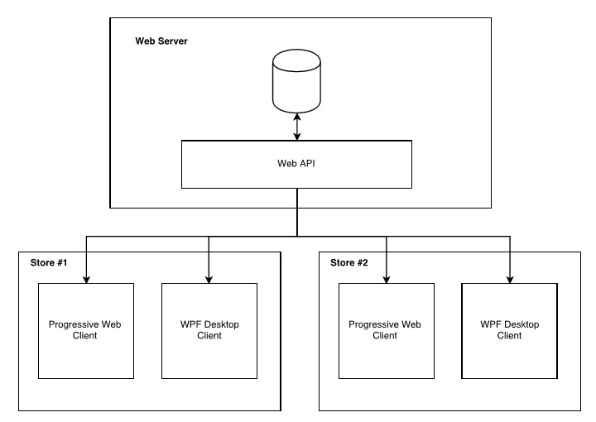Also, support for these architectures…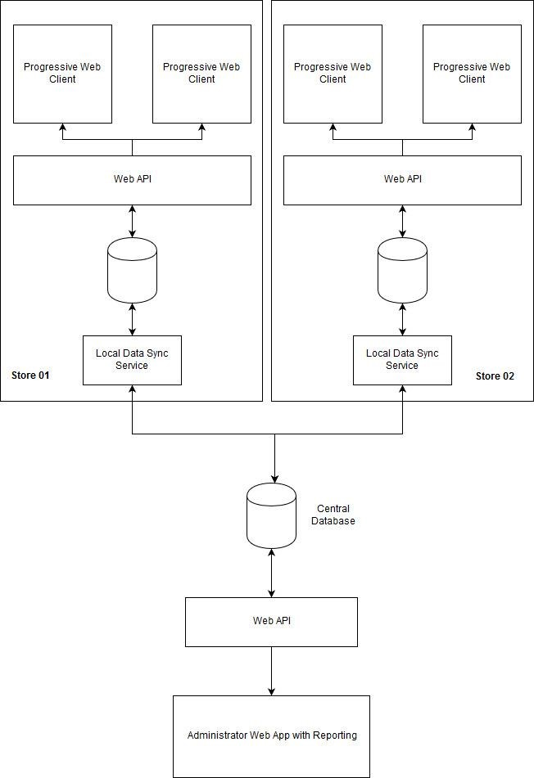

Figure 2: Multiple Stores with Web Server

Figure 3: Local Sever or Web Server

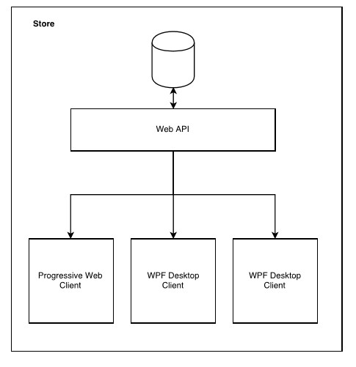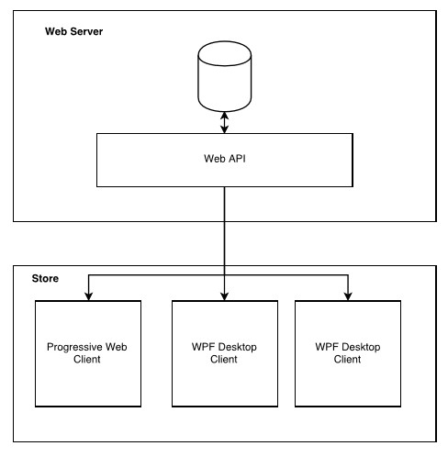

Figure 4: Multiple Stores with Local Servers and Sync data with Web Server

## Key Benefits

The IMS is responsible for maintaining up-to-date status of the inventory and sales done at the organization. Achievable benefits through the new system can be summarized as follows.

* User-friendliness as it is customizable
* The REST API is beneficial in following ways.
  + Evaluation of the system, Maintenance and Further development becomes easy as REST protocol separate business logic and the user completely, as it improves the portability of the interface to other platforms, allowing different components of the development to evolve independently [3]
  + Have to implement the business logic once for multi-platform users
  + Enhances security of data since access can be restricted
* Up-to-date inventory status

Since many of the functions related to inventory are carried out through web application, real-time amendments are done.

* Reliable always up and running invoicing

* A range of reports which will satisfy the statistical requirements

# Objectives

## Employee management and authentication

Every organization have human resource management tasks to be achieved.

This function is responsible for entering core information about the company to the system, then initialize state admin, and customize delivered functions. Other than that, regular features such as adding new members, revoke access types for different users and implementing routes and maintaining user log are implemented in this function.

* System Initializing
* Employee Management
* User Account Management
* User Roles Management
* User Privileges Handling
* Branches Management
* Routes Management
* User Logs Management
* Higher Authorization Request
* Reports Generating

## Products management

Handling details about the products issued to outlet is done in this section. That means, Product categorization with price codes, tracking the physical location of a product, customized labeling and ensures the aftermath of expired product notification.

* Add, Update, Delete Products
* Categories & Subcategories price codes, add, update, delete & display
* Products Sections managing
* Label generating
* Products expire notifications handling.
* Reports generating

## Customer and Loyalty Cards Management

This function is responsible for registering a customer to the system as a loyalty customer and handling credit limits, loyalty points addition and redemption, handling online pre-order requests.

* Add, delete, update & view customer
* Customer credits limit handling
* Customer registrations (Sign Up/Login)
* Loyalty Cards add, update, delete, view
* Loyalty points handling
* Loyalty points redeem
* Pre-Order request add, delete, update display
* Reports generating

## Supplier Management and Stocks Ordering

This function handles Automatic order calculations comparing statistics from previous year.

* Automatic order calculation
* Additional cost handling
* Supplier management
* Supplier payment handling
* Returning day notifications
* Reports generating
* External services handling

## Promotion and Discounts scheduling and management

Sales offers and discounts is one of the major aspects of promotional mix. [4] Discounts can be a price deal depending on Festive season, non-cumulative quantities, trade-up credit, Educational or Student/discipleship, Employee discount and age-related discounts while Promotions can be price-pack or bonus pack deals, checkout dispensers and related cents-off deals, and sampling. [5] Since our concern is to create a system which is deployable in any organization, we are going to handle all the types of discounts and promotions mentioned above.

Also, our system enhances Range of gift vouchers are issued with a unique and unpredictable code ensuring neither misuses nor theft.

* Discount schedule add, update, delete & display
* Promotions schedule add, update, delete & display
* Gift vouchers handling
* Reports generating on the discounts and promotion schedules
* Promotion expire notification is displayed under following circumstances
* When an offer is declared expired by the management
* When the offer is based on a particular stock and that reserved stock is over

This expiration notification also helps users to remind to delete the particular schedule details.

## Stock Management, Return and Wastage management

Stock management part of this function is about assessing the inventory by ensuring the possibility to meet the demand and prevent running out of critical material and goods.

Return and wastage management is also handled through the system as efficient reverse logistics and inbound returns can enhance the value recovery and reselling when done adhering to state laws.

* Stocks add, update, delete, & display
* Trans in/out stocks handling
* Recounting stocks and rectifying
* Promotional stocks handling
* Products returned to suppliers
* Products returning from customers and replacements
* Updating stocks with returning goods
* Generate Low-stock notification
* Wastage stocks handling/updating the inventory
* Report Generating

## Promotion Delivery and Shipment management

This function is useful for an organization which is willing to provide delivery facilities.

Initially, the delivery details are recorded and payment is processed.

Once an order is initialized, the status of the order are being updated time to time until it is confirmed as delivered.

* Order delivery
* Availability of products and requested delivery mode
* Pending confirmation and maintaining status of the delivery
* Cost handling relevant to the invoice
* Report generating

## Invoice handling

When it comes to sales, invoicing is an unavoidable chore which is valuable to customers. It adds some meticulousness for a company. [6]

This function is among the most essential as it should be up and running almost 24/7, regardless of reckless situation such as connection failure. There are several types of invoices basically those issued at the checkout, invoices of return goods etc. the function is going to handle (issuance, updating of products and stocks, calculate discounts based on the items etc.) those as well as address the common tedious practical situations such as bill holding and record multiple paying for a single invoice.

* Add purchased items to Invoice
* Invoice Add and Print Bill, Edit, Delete
* Customer return items invoice handle
* Multiple payment methods for single
* Multiple Invoice holding
* Syncing local DB from Web API
* Internet connectivity checking & data source selection
* Reports generating

# Procedure

## 3.1 Flow of the Project

The system will be built on six main phases (excluding feasibility study) using agile software development methodology. Our main goal is developing a working product and the end of each phase. We decided to use agile because time plays a critical factor and at the end, working software is more important.

### Feasibility Study

In this phase, we decided whether the project is financially and technically feasible. Software we are going to use are Visual Studio 2017, Brackets, Sublime text, MS SQL etc. Some of the software are open source and others we got free of charge from Microsoft Imagine. So the software requirement was financially feasible. We also considered the amount of time we got which is about 14 weeks. This prevented us from expanding our system furthermore. For example, first we thought of developing a mobile application and decided against it. We assigned equal amount of work to each member and all members agreed to work on their assigned function.

### Requirements Gathering

In this phase, we arranged face to face interviews with the client. First, we thought going for a fully web based project. But because of some functions such as Invoice management we decided to develop a desktop application as well. According to the client our aim is to create an IMS which can be deployed at many types of organizations such as supermarkets, bookshops etc. So, the requirements cover a wide scope. Since we do not aim for a specific organization we came up with requirements to resolve problems in an existing IMS system. These problems include Usability issues, Products and stocks related Issues, User and authentication issues, Billing and invoicing and Promotional and discount schedules.

### Requirement Analysis

After gathering the requirements next step was to organize the requirements and divide them into 8 main functions. These parts were then divided into sub functions.

### Requirements specification

This is the phase where requirements are documented in the SRS (Software Requirement Specification document). All the functional requirements, non-functional requirements and constraints of the system are identified and documented. Clients’ approval of the SRS is required to begin the next phase.

### Designing

Technologies which are going to be used to build the system will be decided and finalized. Then High level and low-level diagrams of the system will be drawn.

### Module Implementation and Unit Testing

In implementation, first we are going to implement a prototype that contains user interfaces. This mainly focuses on the front end. Here we do the web development using AngularJS 2, jQuery, HTML and bootstrap. In parallel desktop application is developed using with C#, ADO.NET, XAML, WPF application and SQLite Database. In the second stage we focus mainly on the backend. Which is developing the web API. Each member individually develops the function they chose and tests it.

### Integration and System Testing

Finally, all the unit tested modules are integrated one by one. During the integration, each sub modules which will outcome in the integration process are tested for errors and will be corrected if any found. At the end the whole system is tested and ensured that the system meets the requirements specified in the System Requirements Specification (SRS) document.

## Project Plan

|  |  |
| --- | --- |
| TASK DESCRIPTION | TASK ID |
| Feasibility Study | 1 |
| Requirement Gathering | 2 |
| Requirement Analyzing | 3 |
| Project Charted Document | 4 |
| Planning the System | 5 |
| Proposal Documentation | 6 |
| Proposal Presentation | 7 |
| Designing ER Model | 8 |
| SRS Documentation | 9 |
| Making Mocks Objects | 10 |
| Planning GUI | 11 |
| Planning the WebAPI | 12 |
| Coding Web UI | 13 |
| Coding WPF Application | 14 |
| Make Data Models | 15 |
| Build the Prototype | 16 |
| Prototype Presentation | 17 |
| Coding Final System | 18 |
| Unit Testing | 19 |
| Integration Testing | 20 |
| Acceptance Testing | 21 |
| Final Presentation | 22 |

Table 1: Project Plan - Tasks & Task IDs

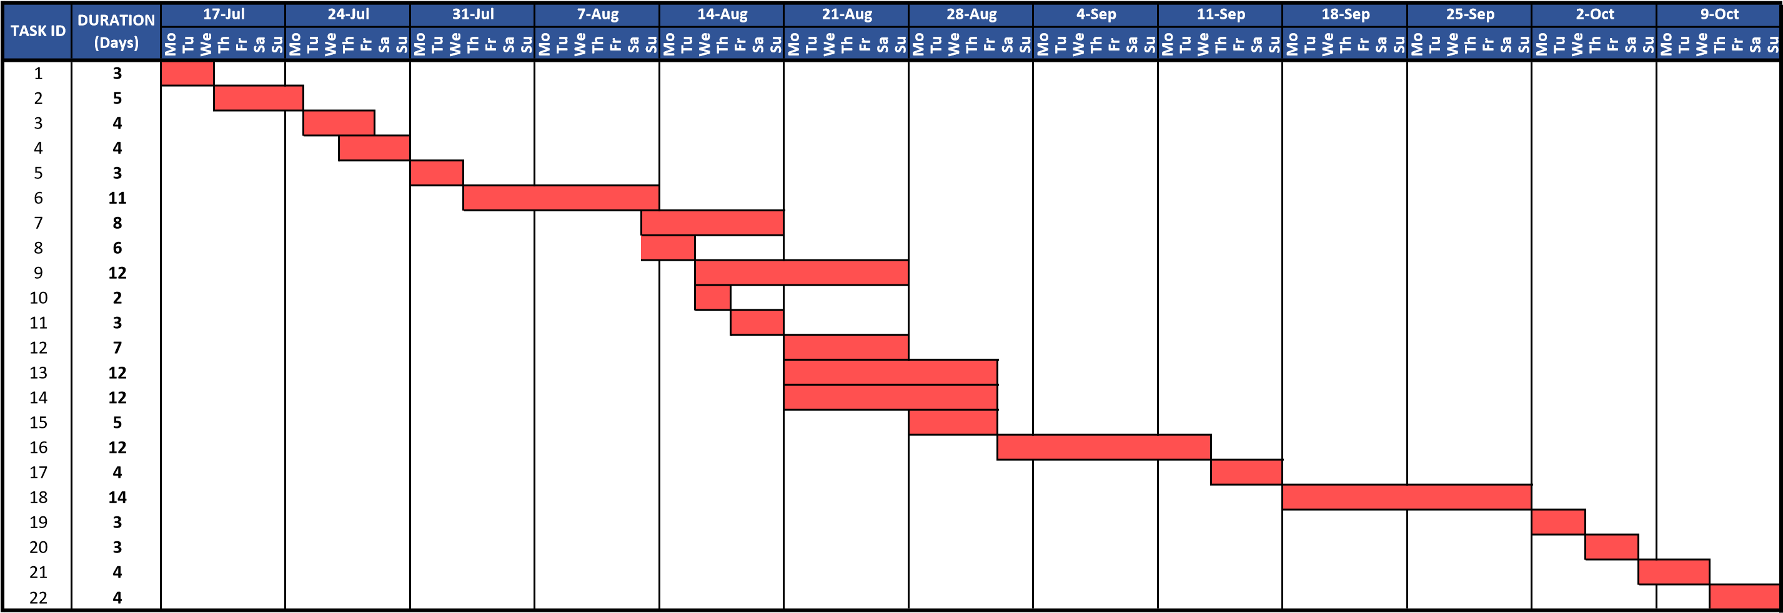

Figure 5: Gantt Chart

# Personnel and Facilities

|  |  |  |  |
| --- | --- | --- | --- |
|  | SLIIT ID | Name with Initials | Roles |
|  | IT16158764 | Basnayake M.C.S.B | Sales & Invoice Management |
|  | IT16160330 | Amarasinghe U.P.A.S.D | Employee Management & Authentication |
|  | IT16154490 | Rodrigo U.S.D | Promotions Schedules & Discounts Schedules Managements |
|  | IT16423534 | Bimali Y.M.Y | Stocks Managements |
|  | IT16225916 | Rajapakshe R.W.D.K.P | Suppliers Management & Stocks Ordering |
|  | IT16130562 | H.S.K Wijesekara | Products Managements |
|  | IT16161566 | U.S.O Vindula | Return & Wastage Management |
|  | IT16133914 | L.L.K.S Lokuge | Customers & Loyalty Cards Management |

*Table 2: Personnel and Facilities*

## Common roles:

Requirement gathering and analysis

Interface and module designing

Documentation

Testing

## Resources:

Sublime text, Visual code, Brackets

Visual Studio 2017 – Community Edition

Postman, Fiddler 4

# Software and Hardware Requirements

## Software Requirements

* + Web Application
    - Any Updated Web Browser
      * Any Platform.
* WPF Application
  + Windows 7 Service Pack 1 or above
* Windows 10 recommended

## Hardware Requirements

* + Web Application
    - 512MB RAM recommended
* WPF Application
  + 1GHz processor, Dual Core processor recommended
  + 512MB RAM
  + 1GB storage recommended (Depends on database size)
  + Printer (Optional)
  + Barcode Reader (Optional)

# Budget

|  |  |  |  |  |
| --- | --- | --- | --- | --- |
| Category | Description | Qty | Unit Price | Total Cost |
| Stationary | A4 Bundle  Pen  R/W DVD | 1  10  3 | 500  15  75 | **950.00** |
| Travelling | Cost for travelling | | | **3 000.00** |
| Communication | Cost for calls and Short Messaging Service(SMS) | | | **2 500.00** |
| Printing | Printouts  Binding  Photocopy | | | **1 500.00** |
| Internet and  Browsing | Cost of internet charges | | | **9 000.00** |
| Hardware | Bar code reader  Invoice Printer  Server | | 10000  20000  6000 | **36 000.00** |
| Others |  | | | **2 000.00** |
| Total Cost |  | | | **54 950.00** |

Table 3:Budget Table

*All Prices in Sri Lankan Rupees.

# References

World Wide web

[1] santiago, k. (2017). *Sales and Inventory System Thesis Documentation*. [online] Academia.edu. Available at: https://www.academia.edu/16863814/Sales_and_Inventory_System_Thesis_Documentation [Accessed 6-Aug-2017]

[2] C.A.P. Calicdan, Warehouse management system on RFID. 2013, p.4,5

[3] BBVAOpen4U. (2017). *REST API: What is it, and what are its advantages in project development?* [Online] Available at: https://bbvaopen4u.com/en/actualidad/rest-api-what-it-and-what-are-its-advantages-project-development [Accessed 6 Aug. 2017].

[4] YourArticleLibrary.com: The Next Generation Library. (2017). *4 Most Important Elements of Promotion Mix | Business Marketing*. [Online] Available at: http://www.yourarticlelibrary.com/marketing/4-most-important-elements-of-promotion-mix-business-marketing/8796/ [Accessed 9 Aug. 2017].

[5] En.wikipedia.org.(2017). *Promotional mix*[online] Available at: https://en.wikipedia.org/wiki/Promotional_mix [Accessed 9 Aug. 2017].

[6] Marin, M. (2017). *Managing Receivables: Importance of Promptly Invoicing Customers*. [Online] Business Financial Fitness Program| Gateway Commercial Finance. Available at: https://gatewaycfs.com/bff/managing-account-receivables [Accessed 9 Aug. 2017].